

IBM Watson Machine Learning - Sample2 Deployment



Table of Contents
1 Document purpose 3
2 Prerequisites 4
2.1 Bluemix 4
2.2 Cloud Foundry 4
2.3 Node.js 5
2.4 Downloading Sample 2 6
3 IBM SPSS Modeler 7
4 Bluemix application and service 8
4.1 Creating the application 8
4.2 Creating the service 10
5 Customizing files 13
5.1 \app\manifest.yml 14
5.2 \app\app.js 14
5.3 \app\public\js\app.js 14
5.4 \app\public\js\srv.js 14
6 Porting source code 15
6.1 Node Package Manager 15
7 Uploading SPSS Models 17
8 Real-Time scoring the sample 18

Document purpose
This document outlines how to configure and run the IBM Watson Machine Learning Sample2 (https://github.com/pmservice/predictive-modeling-samples).

- This document compliments the current documentation associated with Sample2.
- This document interfaces with an IBM SPSS Modeler stream, but the focus is on Bluemix. It’s assumed that the reader has a basic understanding of predictive analytics used in IBM SPSS Modeler.
- While there are many supported runtimes in Bluemix (Liberty for Java, Python, Ruby, ASP.NET, Swift, Tomcat, etc.), this document uses SDK for Node.js.
- Other operating systems are supported, but this example uses Microsoft Windows.

Prerequisites

Bluemix
- Ensure that you have a valid Bluemix account.

Cloud Foundry
- Install the Cloud Foundry (CF) Command Line Interface from https://github.com/cloudfoundry/cli/releases.
- Ensure that the tool is running properly by typing the following at a command prompt:
cf
You should receive output that looks similar to the following:
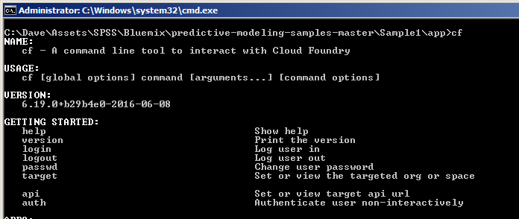
Note: You may need to reboot your system in order for it to locate the cf executable. Do not proceed until the cf command runs.

Node.js
Node.js is required to download supporting code from Bluemix to the local development environment. Additional information can be found at https://nodejs.org/en/about/.

- Download and install Node.js from https://nodejs.org/en/download/.
- Validate that Node.js is running properly by typing the following at a command prompt:
npm
You should receive output that looks similar to the following:
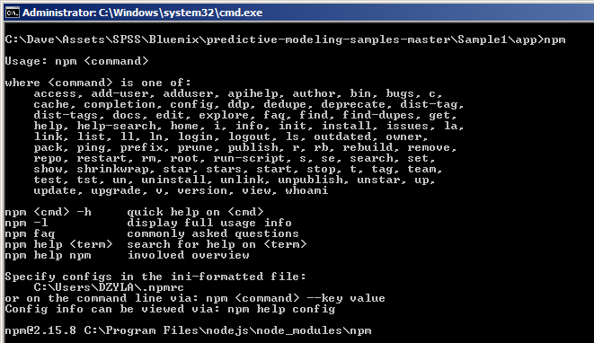
Note: You may need to reboot your system in order for it to locate the npm executable. Do not proceed until the npm command has run.

Downloading Sample 2
- Download Sample 2 from https://github.com/pmservice/predictive-modeling-samples.
- Extract the contents to a working directory. This example uses C:\SPSS.
- Once extracted, your folder structure should look like this:
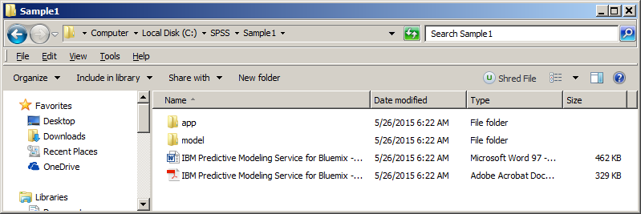

IBM SPSS Modeler
The sample comes with an SPSS Modeler stream at C:\SPSS\Sample1\model\Drug1n.str.

It is important to note that a scoring branch has been set in the stream. Any model used in the Bluemix Machine Learning node must have a scoring branch set. This can simply be done by right-clicking the terminal node and selecting Use as scoring branch.
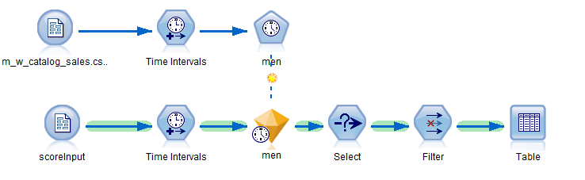

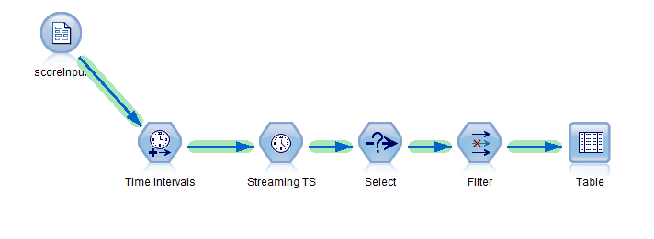
The Bluemix application must provide the same data items used in the input node. In this case, it’s the scoreInput node.

Bluemix application and service

Creating the application
- Log in to Bluemix.
- If you don’t already have a space created, create one now. You can use whatever name you’d like, but make note of the name for future reference.
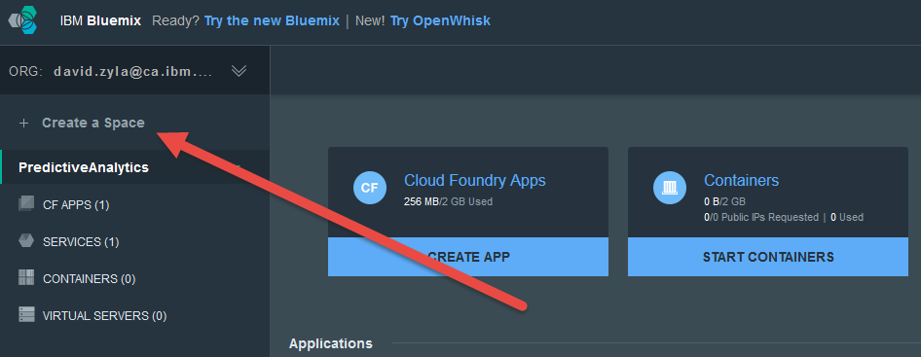
- After creating the new space, click it on the left side of your screen.
- On the top of the page, click Create app.
- Choose WEB.
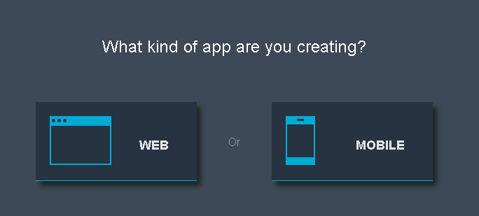
- Select SDK for Node.js.
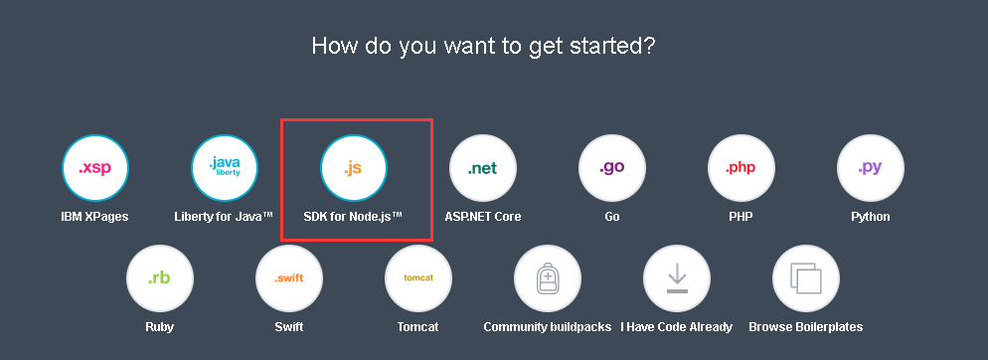
- Name the new application as desired, but use a short name. This example uses SPSSSample.
- Click Create to stage and create the application. This process may take a minute or two to complete.
- After the application is created, go back to the dashboard. You should see the new application.
- Click the application, and then go to the application overview page. In the top right corner, find the settings icon.
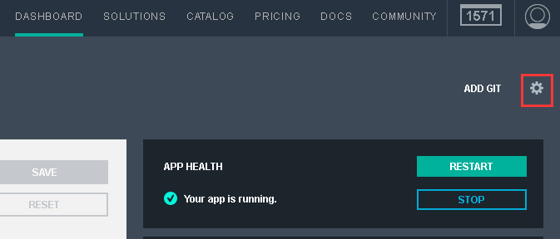
- Click the settings icon and select Edit Routes and App Access.
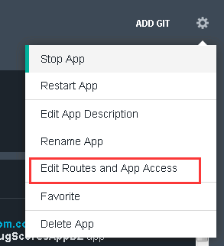
- The second selection box displays this app's domain name:
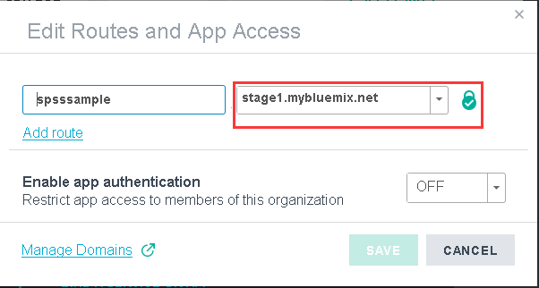
- Take note of the Space, App Name, Host, and Domain as they will be referred to later on.

Creating the service
- Ensure that the SDK for Node.js application is running and is selected on the left side of the screen.
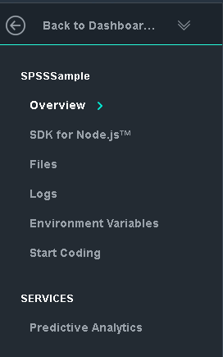
- On the upper toolbar, click Catalog.
- To filter the number of services displayed, select Data and Analytics under Services on the left side of the screen.
- Click IBM Watson Machine Learning.
- On the Add Service screen, ensure that the App drop down is changed from Leave Unbound to the application you created previously. This binds the service to the application.
- Take note of the app and service names.
- Click Create. If prompted to re-stage, select Yes.
- Navigate back to the top dashboard page to display both the application and service.
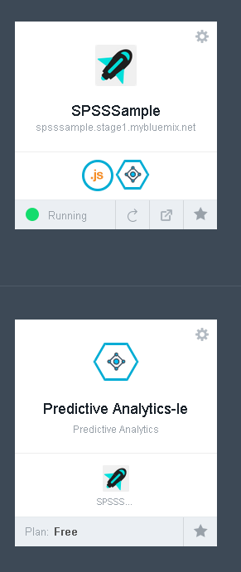
- Click the application (SPSSSample).
- When we score the input data in this example, credentials must be supplied to Bluemix at runtime. Click the up arrow to show the credentials.
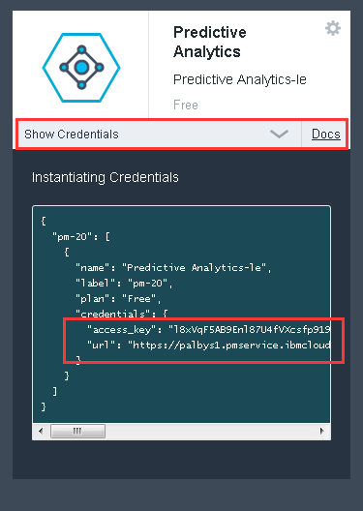
- In the fly-out window, take note of the the access key and URL. You will need these later.
- At this point in time, the application and service containers are ready.

Customizing files
This section discusses customization of the files that were downloaded to the SPSS working directory C:\SPSS\Sample1.

\app\manifest.yml
Manifest.yml contains information about the deployment, and is typically used to reduce the number of deployment details you must specify every time you deploy an application to Bluemix.
- Open the file C:\SPSS\Sample2\app\manifest.yml in a text editor.
- Change the value of the host variable to reflect what was used in the Creating the application section previously. In this example, SPSSSample was used.
- Change the value of the name variable to reflect what was used in the Creating the application section previously. In this example, SPSSSample was used.
- Change the value of the domain variable to reflect what was used in the Creating the application section previously. In this example, mybluemix.net was used
- Change the value of the memory variable to 256M.
- Add the following line:
disk_quota: 1024M
- Save and close the file.

\app\app.js
- Open the file C:\SPSS\Sample2\app\app.js in a text editor.
- Navigate to line 21 and update the defaultBaseURL that was recorded in the Creating the service section previously. Note that the <> must be removed and the entire string value must be enclosed in single quotes (‘’).
var defaultBaseURL = 'https://palbyp.pmservice.ibmcloud.com/pm/v1';
- Similar to the previous step, update the defaultAccessKey value key on line 22.
- Save and close the file.

\app\public\js\app.js
- Open the file C:\SPSS\Sample2\app\public\js\app.js in a text editor.
- Navigate to line 8.
- Note that the value of the $scope.context variable is ['catalogTS', 'catalogSTS']. While no change is required in this file, be aware that every SPSS model scored in Bluemix must have a unique context ID. This will be discussed further in the Uploading SPSS Models section.
- Close the file. No change is required.

\app\public\js\srv.js
- Open the file C:\SPSS\Sample1\app\public\js\srv.js in a text editor.
- Navigate to line 14. Note that the tablename variable matches the name of the source node in the SPSS Modeler model.

- Close the file. No change is required.

Porting source code

Node Package Manager
The Node Package Manager utility downloads supplemental files from Bluemix. The Start Coding section of the Bluemix application provides some of the commands that will help you connect to your Bluemix environment. It may be easier to use the commands there than to customize the following steps.
- Launch a command prompt.
- Change to the directory C:\SPSS\Sample2\app.
- Type the following command to connect to IBM Bluemix:
bluemix api https://api.ng.bluemix.net
- Type the following command to log in to Bluemix:
bluemix login -u david.zyla@ca.ibm.com -o david.zyla@ca.ibm.com -s SPSS_RT_Scoring
- Type your password when prompted.
- Type the following command to download the supplemental files:
npm install
This creates the directory C:\SPSS\Sample2\app\node_modules.
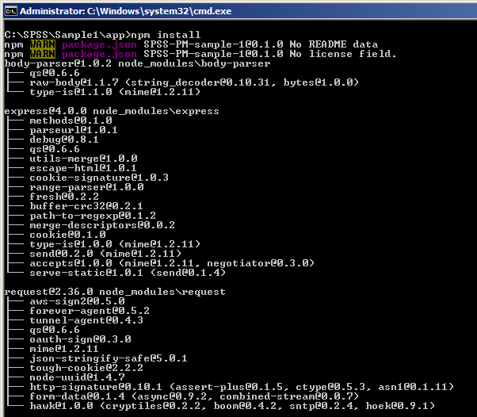
- To push all files and the customizations that were made, run the following command:
cf push <Application Name>
cf push SPSSSample2
The application is uploaded to Bluemix.

Uploading SPSS Models
At this point, we have uploaded our custom application to IBM Bluemix. But we still need to provide Bluemix with the SPSS models that we want to use.
- Launch a browser and log in to Bluemix.
- From the dashboard, click the Machine Learning service that was created previously.
- In the bottom right corner, note there’s a New Model Stream section. The SPSS model we’re going to provide can be found in the following locations:
C:\SPSS\Sample2\model\catalog_timeseries.str
C:\SPSS\Sample2\model\ catalog_streaming_timeseries.str
Upload the model either by dragging and dropping it or by using the Select File option.
- You will be prompted to provide a Context Id. While this ID can be anything, for this example, . catalog_timeseries.str uses catalogTS and catalog_streaming_timeseries.str uses catalogSTS.
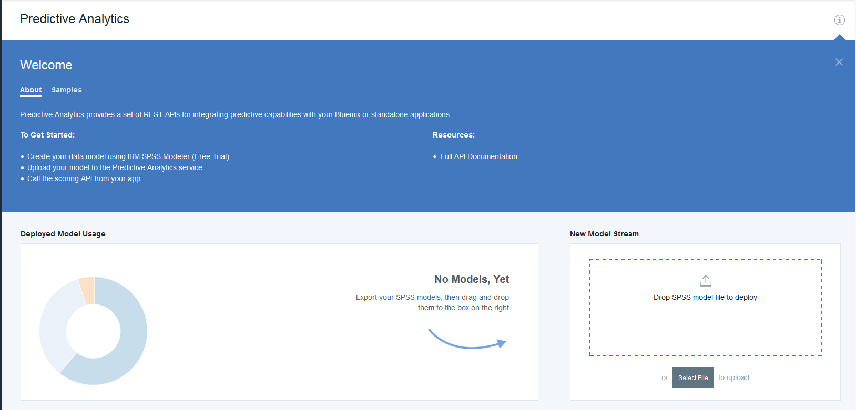
- Click Deploy.
- The model is listed in the bottom section of the screen.
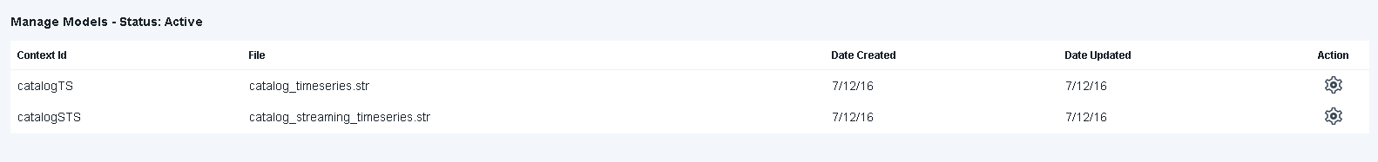

Real-Time scoring the sample
- In Bluemix, navigate to your Dashboard.
- Click the application you created. At the top of the screen, you can see the URL for accessing your application:

- Click the URL. Your real-time scoring application opens:
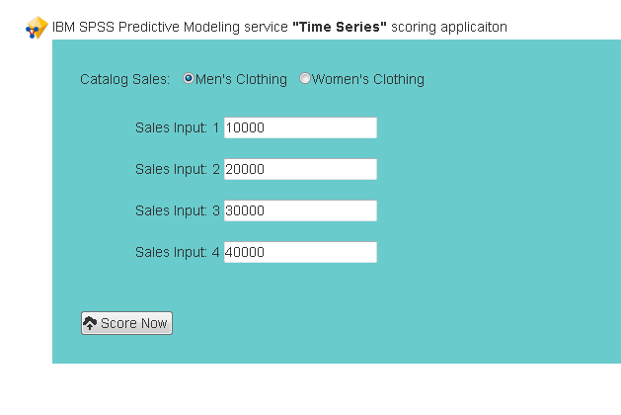
- You can change any of the values as desired, then select Men’s Clothing or Women’s Clothing to simulate data being entered by a user of the application.
- Click Score Now.
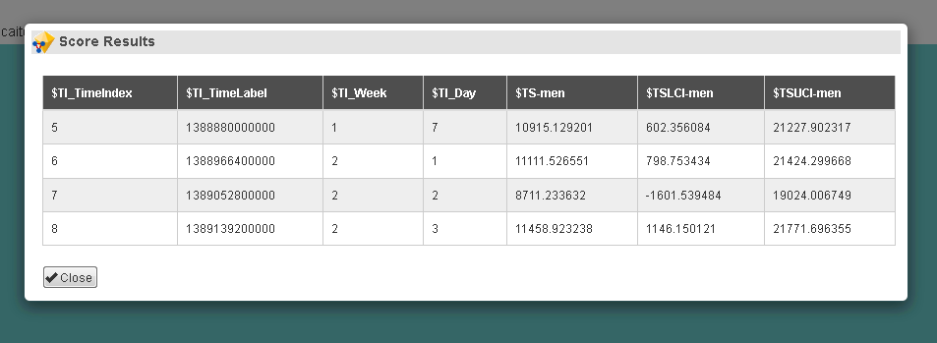
This example displayes the input along with the predicted drug and predicted confidence.

This document has walked through the process of:
- Setting up the necessary development tools
- Customizing the sample code
- Uploading an SPSS model
- Scoring the SPSS model with data provided in real-time

